Lab 02: Introduction to Limiting Reagents and Theoretical Yields
In all the examples discussed thus far, the reactants were assumed to be present in stoichiometric quantities. Consequently, none of the reactants was left over at the end of the reaction. This is often desirable, as in the case of a space shuttle, where excess oxygen or hydrogen was not only extra freight to be hauled into orbit but also an explosion hazard. More often, however, reactants are present in mole ratios that are not the same as the ratio of the coefficients in the balanced chemical equation. As a result, one or more of them will not be used up completely but will be left over when the reaction is completed. In this situation, the amount of product that can be obtained is limited by the amount of only one of the reactants. The reactant that restricts the amount of product obtained is called the limiting reactant. The reactant that remains after a reaction has gone to completion is in excess.
Consider a nonchemical example. Assume you have invited some friends for dinner and want to bake brownies for dessert. You find two boxes of brownie mix in your pantry and see that each package requires two eggs. The balanced equation for brownie preparation is thus
1 box mix + 2 eggs → 1 batch of brownies
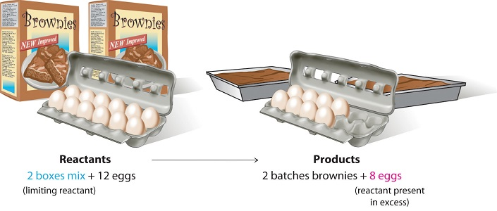
If you have a dozen eggs, which ingredient will determine the number of batches of brownies that you can prepare? Because each box of brownie mix requires two eggs and you have two boxes, you need four eggs. Twelve eggs are eight more eggs than you need. Although the ratio of eggs to boxes in is 2:1, the ratio in your possession is 6:1. Hence the eggs are the ingredient (reactant) present in excess, and the brownie mix is the limiting reactant. Even if you had a refrigerator full of eggs, you could make only two batches of brownies.

Consider this concept now with regard to a chemical process, the reaction of hydrogen with chlorine to yield hydrogen chloride:
H₂+Cl₂(g)→2HCl(g)
The balanced equation shows the hydrogen and chlorine react in a 1:1 stoichiometric ratio. If these reactants are provided in any other amounts, one of the reactants will nearly always be entirely consumed, thus limiting the amount of product that may be generated. This substance is the limiting reactant, and the other substance is the excess reactant. Identifying the limiting and excess reactants for a given situation requires computing the molar amounts of each reactant provided and comparing them to the stoichiometric amounts represented in the balanced chemical equation. For example, imagine combining 3 moles of H₂ and 2 moles of Cl₂. This represents a 3:2 (or 1.5:1) ratio of hydrogen to chlorine present for reaction, which is greater than the stoichiometric ratio of 1:1. Hydrogen, therefore, is present in excess, and chlorine is the limiting reactant. Reaction of all the provided chlorine (2 mol) will consume 2 mol of the 3 mol of hydrogen provided, leaving 1 mol of hydrogen nonreacted.
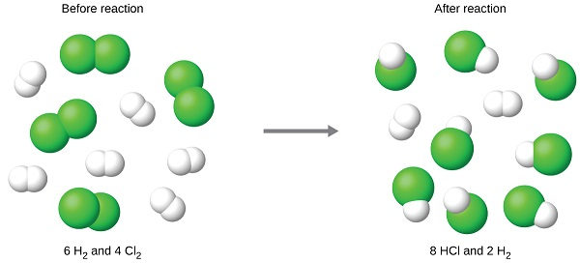
An alternative approach to identifying the limiting reactant involves comparing the amount of product expected for the complete reaction of each reactant. Each reactant amount is used to separately calculate the amount of product that would be formed per the reaction’s stoichiometry. The reactant yielding the lesser amount of product is the limiting reactant. The chlorine will be completely consumed once 4 moles of HCl have been produced. Since enough hydrogen was provided to yield 6 moles of HCl, there will be non-reacted hydrogen remaining once this reaction is complete. Chlorine, therefore, is the limiting reactant and hydrogen is the excess reactant

When H₂ and Cl₂ are combined in nonstoichiometric amounts, one of these reactants will limit the amount of HCl that can be produced. This illustration shows a reaction in which hydrogen is present in excess and chlorine is the limiting reactant.
A similar situation exists for many chemical reactions: you usually run out of one reactant before all of the other reactant has reacted. The reactant you run out of is called the limiting reactant; the other reactant or reactants are considered to be in excess. There are two ways to determine the limiting reagent. One method is to find and compare the mole ratio of the reactants used in the reaction (Approach 1). Another way is to calculate the grams of products produced from the given quantities of reactants; the reactant that produces the smallest amount of product is the limiting reagent (Approach 2). This section will focus more on the second method.
Approach 1 (The "Reactant Mole Ratio Method"): Find the limiting reagent by looking at the number of moles of each reactant.
- Determine the balanced chemical equation for the chemical reaction.
- Convert all given information into moles (most likely, through the use of molar mass as a conversion factor).
- Calculate the mole ratio from the given information. Compare the calculated ratio to the actual ratio.
- Use the amount of limiting reactant to calculate the amount of product produced.
- If necessary, calculate how much is left in excess of the non-limiting reactant.
Approach 2 (The "The Product Method"): Find the limiting reagent by calculating and comparing the amount of product each reactant will produce.
- Balance the chemical equation for the chemical reaction.
- Convert the given information into moles.
- Use stoichiometry for each individual reactant to find the mass of product produced.
- The reactant that produces a lesser amount of product is the limiting reactant.
- The reactant that produces a larger amount of product is the excess reactant.
- To find the amount of remaining excess reactant, subtract the mass of excess reactant consumed from the total mass of excess reagent given.
What flask do you think will produce the most gas and why?

- Label three Erlenmeyer flasks with number 1, 2, and 3 before proceeding with the experiment.
- Fill each flask with quantities of white vinegar indicated in the table below.
- Prepare three rubber balloons containing the quantities of baking soda indicated in the table below
- Fasten the end of the balloon atop of the opening of each corresponding Erlenmeyer flask.
- Slowly invert the contents of each balloon into the Erlenmeyer flask containing the vinegar and observe the volume of carbon dioxide gas that is expelled from the balloon.
- Complete the table below and prepare your formal lab report using the template provided. Ensure you provide all calculations of the limiting reagent and theoretical yields in the Quantitative Analysis and Data Collection portion of the lab report.
 | Flask #1 | Flask #2 | Flask #3
Mass of Baking Soda | 1.50g | 3.50g | 5.50g
Mass of Vinegar | 50.0g | 50.0g | 50.0g
Qualitative Observations
Theoretical Yield
Overall Reaction | NaHC0_{3(s)} + C₂H₄O_{2(l)} NaC₂H₃O_{2(s)} + H₂0_{(l)} + CO_{2(g)}
CO₂

CO₂
CO₂
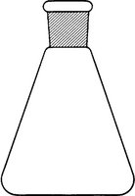


2
3
1
2
1

